ETL Processing Final

In this final you will create an entire Business Intelligence solution. This activity will take you about 15 to 20 hours, so plan accordingly!

The activity consists of the follow steps:

- Review the chapters from your textbook.
- Review and Estimate using the "Final Checklist.xlsx” file.
- Create the OLTP Database with Instructors Script
- Design a Data Warehouse
- Start the Solution Developer Document in Excel
- Create a Data Warehouse script
- Create an ETL script
- Create an SSIS ETL project and package
- Create an Excel workbook with a DW report
- Update the Solution Developer Document in Excel
- Create a Technical Overview Document
- Write a one-page report on what you learned in this class.
- Update the “Final Checklist.xlsx” file.
- Submit a BI Solution to the Canvas site.

Review the chapters from your textbook
You will be creating a new BI solution using databases provided by your instructor! This means that you may have to review many of the chapters in the book as needed.

Review and Estimate using the Final Checklist.xlsx” file.
Use the provide file to estimate the number of hours you think this will take and plan your work. This is in addition to the other Excel document that is used for planning the BI solution. Students get very worried about this, but all you need to do is make an educated guess so you can how close or how far off you were at the end of the project. So, just guess and see what happens!

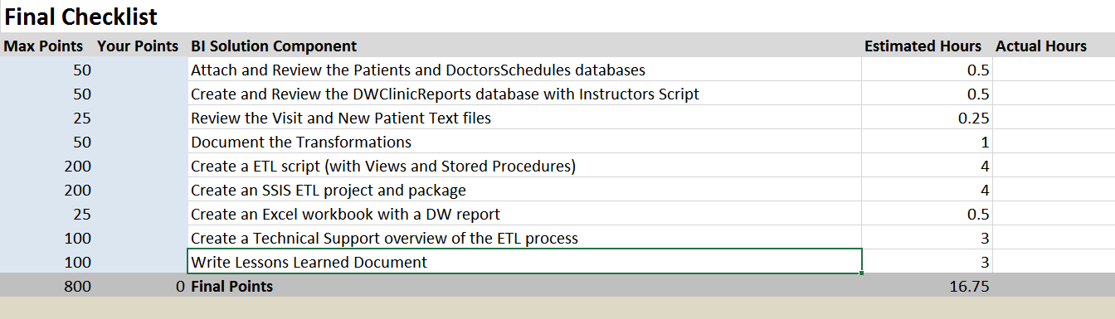

Create the OLTP Database with Instructors Script
You need to attach two source databases provide by your instructor called
Patients and DoctorsSchedules. The .MDF files for each database is include with the final's zip file. You will also find a set of .CSV files that need to be added daily to the source databases. Review each database and file, noting the many issues in their design and data!

Note: You will need to use regular expressions to clean the addresses.

Create a Data Warehouse
I have given you a data warehouse database script, to create ETL destination database. Review this database, noting its design!

Start the Solution Developer Document in Excel
You need to create an Excel that documents your development of the BI solution. You can use the Excel spreadsheet from module 01 as a template or make one from scratch. Fill the spreadsheet with the source, destination, and transformation meta data.

Create an ETL script
You need to create an ETL SQL script for your solution. Make sure it includes views and stored procedures.

Create an SSIS ETL project and package
You need to create an SSIS ETL project and package for your solution.

Create a Technical Overview Document
At that point you need to update your Excel development document to accurately record the objects in your BI solution. The reason for this is that things tend to change as you go through the creation of the BI Solution, and you need to make sure your final documentation reflects what was built. Next you need to create a technical document that describes the ETL process you have created. The reader should be able to read your documents and understand what all the solution's components are, why are used, and how they are used.

Write a one-page report on what you learned in this class
Write a paper that outlines what you have learned in this class. This helps both you and I to understand you progress in this class. You may be surprised to see that this process solidifies what you have learned (or at least other students have told me it does!) There is no need to make this an exhaustive coverage of what you did, so make the paper to about a single page of text and it will be fine.

Note: This is a college level class and I expect college level writing and formatting. It does not have to be perfect, but if you turn in a blob of text without a header or citing it will cost you.

If it has been awhile since you learned about this, here are a couple of web pages you should look at. There are many, many, sites that will give you more information, but these include the basics you need to know:

- https://blog.udemy.com/college-essay-format/
- https://owl.english.purdue.edu/owl/resource/747/02/

Update the Final Checklist.xlsx file
Use this file to check that you have complete all the steps and update the number of hours it took to do the final.

Submit a BI Solution to the Canvas site
After you have configured and tested your solution, ZIP the entire BI solution folder and upload it to the Canvas web site. Remember that you will have placed all the files for the ETL scripts, SSIS, Excel ETL and Checklist spreadsheets and Word docs into one solution folder. Zip everything up into one Zip file and submit it to canvas.

You’re done! And this time I really mean it! ☺
Thanks for being in the class!!!

